Dan Schler
EDUC 450
Alternative Assessment
Drawing One
Surrealism Drawing
Due – Dec. 15th
100 Points

Objective:
The goal of this “surrealism” drawing project is to get you, the student to open up your imaginations and explore all the wide possibilities. If you recently had a bizarre dream, that’s great, now let’s put that onto paper! Perhaps you’re a big fan of Salvador Dali and his long-legged elephants or his melting clocks; now’s your turn to make your own creations. This project is like any other art project and will be graded upon your ability to plan, your use of Art Elements/Principles, your creativity, use of personal voice and your craftsmanship/skill (see attached rubric for specifics). Also, we will be having a group critique and we will discuss yours and your peers work.

Colorado Standards:
Standard: 1. Observe and Learn to Comprehend
Standard: 2. Envision and Critique to Reflect
Standard: 3. Invent and Discover to Create

Directions:
Begin to Research. Questions to get you rolling: What is surrealism? What does it incorporate?
Artists to consider: Salvador Dali, Max Ernst, Joan Miro, Rene Magritte, Vladimir Kush.

Once you have a good idea of what surrealism includes…start some preliminary sketches of ideas you have. Students who want to be in the “Advanced” (on the rubric) will include more than three sketches of their ideas. This is also the time for you to explore a variety of drawing materials- Charcoal compared to lead pencil, pastel compared to chalk. Unusual combination of materials and exploration will result in an “advanced” placement of originality.

The next step will be to get into groups of 4-6 and discuss ideas. This is a time to get feedback before the final product. It also allows you to see what your peers think and where they are going with the project. Everyone has a different imagination, it’s just a matter of expressing it. Feel free to steel/share ideas. Originality will be very important! These are to come from you…not a magazine cover or a YouTube clip.

Now begin! You will have 2 weeks to complete this project (Due Dec. 15th). The final Product should look like you spent two weeks on it. This will be reflected in the craftsmanship and exploration of materials. If you finish early…think…there’s probably something else you could add to enhance it.

ABOVE ALL…HAVE FUN AND LET YOUR IMAGINATIONS LOOSE.

Provided are a few examples that can help. These are to help generate ideas…don’t copy! BE ORIGINAL!

Vladimir Kush Pearl
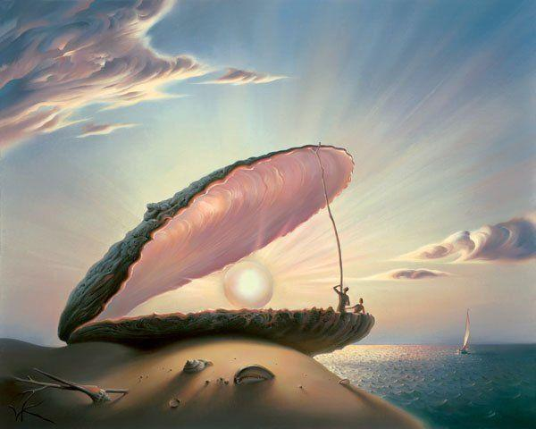

Salvador Dali Original Lithograph
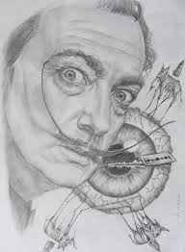

Dan Schler “Scorched Dreams”
